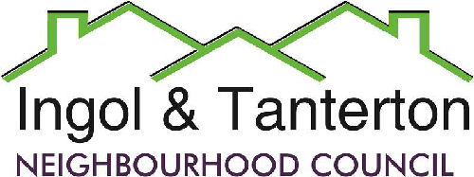

Gill Mason - Clerk and RFO

Email: [ingoltantertonnc@hotmail.co.uk](mailto:ingoltantertonnc@hotmail.co.uk)

**Agenda**

**A meeting of the Ingol and Tanterton Neighbourhood Council Area Enhancement Committee will be held on** **Thursday 26th June at 6.45pm at Tanterton Village Centre.**

1.To receive apologies.

2.To receive declarations of interest and dispensations.

3.To approve the minutes of the meeting held in February 2025.

4.Public participation.

5.To consider the land registry titles and maps of the Tanterton Village Green area.

6.To consider the renovation project and next steps for Tanterton Village Green and Dovedale.

Press and public are welcome to attend.